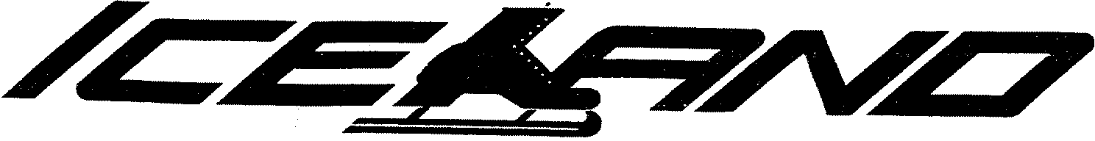
3345 HILLSIDE AVENUE, New Hyde Park N.Y. 11040. 516-746-1100
Birthday Parties
Effective Sept 30th 2023

Birthday Party Package
** Credit and debit card prices reflect a 4% non-cash adjustment**
$240 cash discount $249.60 credit/ debit card for 1ST Ten Children
$23 cash discount or $23.92 credit/debit card Each Additional
- Admission
- Skate Rental
- Choice of Pizza or Hot Dog
- Soft Drink or Fruit Punch
- Soft Pretzel
- All Paper Goods
- FREE Pass (For Birthday Child’s Future Visit)
- Discount Coupons for All Children
- Parent’s FREE (Only Pay for Rentals)
- Party Hostess to Serve Party

-20 Person limit per party

*Dress Warm, Wear Gloves*
*Under 10-Helmets Recommended*
All Prices Subject to Change

Rent A Pro
Half Hour Lesson
$35.00 cash discount each pro
or
$36.40 credit/debit card forEach Pro
(10 Kids Per Pro)
*Kosher Parties Available Inquire in Main Office

